HOTEL REVENUE ANALYSIS
MODULE 3
Customer Segmentation & Behavioural Analysis

1. Objective
To classify hotel guests into distinct segments (Business, Family, Solo) and behavioural clusters (Loyal, High Spender, First-Timer) to enable targeted marketing and personalized services.

2. Creation of Columns in Bookings
2.1 Creating GuestType Column in Bookings
Segments guests based on booking channels or occupancy.
- Go to Data View and select the Bookings table.
- Click new column
GuestType =
SWITCH(TRUE(),
[Purpose] = "Business" || [Booking Channel] = "Corporate", "Business",
[Purpose] = "Vacation" && [Stay_Type] = "Extended Stay", "Family",
[Purpose] = "Wedding" && [Stay_Type] = "Extended Stay", "Family",
[Purpose] = "Conference" && [Stay_Type] = "Extended Stay","Corporate",
"Solo")

2.2 Creating NumOfBookings Column
- Click new column
NumOfBookings =
CALCULATE(
COUNT(Bookings[BookingID]),
ALLEXCEPT(Bookings, Bookings[CustomerID])
)

2.3 Creating CustomerCluster Column:
Assigns a label based on their frequency and spending.

CustomerCluster = SWITCH(TRUE(),
[NumOfBookings] = 1 && [Revenue] <=
5000, "First-Timer",
[NumOfBookings] >= 3 && [Revenue] <
25000, "Loyal Guest",
[Revenue] >= 25000, "High Spender", "Other")
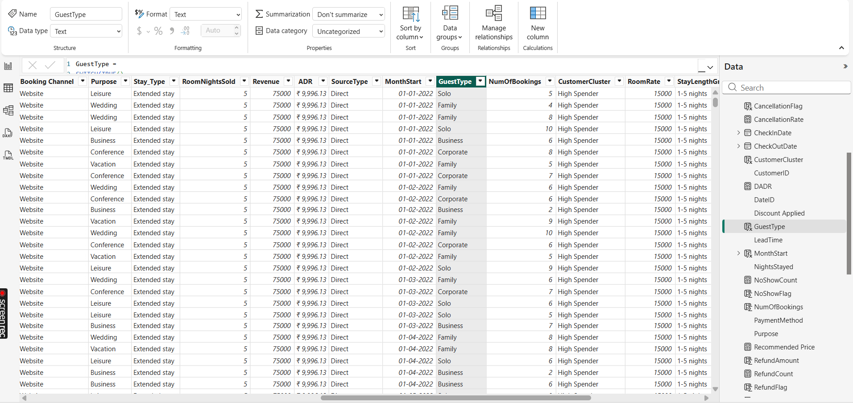

3. Creating Tbl_Guests (Aggregate Table)
Goal: Create a distinct table that aggregates data at the Customer Level to perform RFM Analysis.
- Go to the Modeling tab $→$New Table.
- Paste the DAX code provided

Tbl_Guests =
SUMMARIZE(
'TblBookings',
'TblBookings'[CustomerID],
"FirstStay", MIN('TblBookings'[CheckInDate]),
"LastStay", MAX('TblBookings'[CheckOutDate])
)

- Go to New Column
FrequencyScore =
CALCULATE(
COUNTROWS('TblBookings'),
FILTER('TblBookings', 'TblBookings'[CustomerID] = 'Tbl_Guests'[CustomerID]))

- Click New Column

SpendScore =
CALCULATE(
SUM('TblBookings'[DayRevenue]),
FILTER('TblBookings', 'TblBookings'[CustomerID] = 'Tbl_Guests'[CustomerID]))
- Go to New Column

RecencyScore =
DATEDIFF(
CALCULATE(
MAX('TblBookings'[CheckOutDate]),
FILTER('TblBookings', 'TblBookings'[CustomerID] = 'Tbl_Guests'[CustomerID])
),
TODAY(),
DAY)

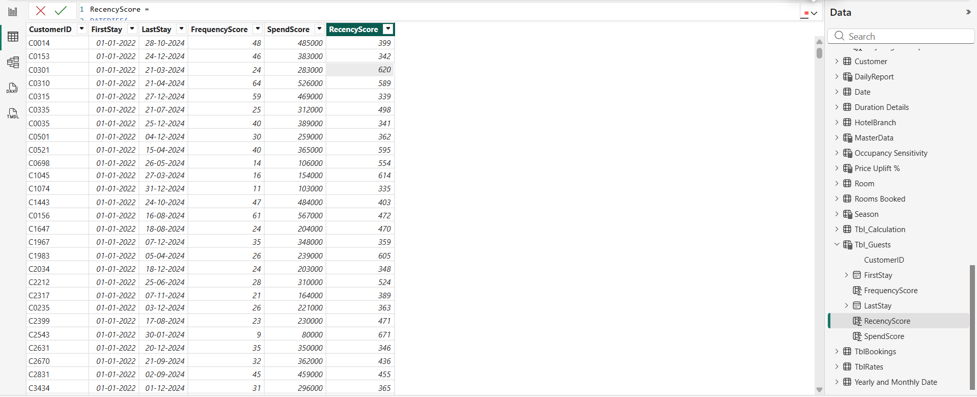

4. Creating Multiple Nationality Records for Customers

In Excel, Go to Customer Table-> Country -> paste this formula in any row and apply to entire table.
=CHOOSE(RANDBETWEEN(1,46),"India", "United States", "United Kingdom", "Canada", "Australia", "Germany", "France", "Italy", "Spain", "Brazil", "Mexico", "China", "Japan", "South Korea", "Russia", "South Africa", "Nigeria", "Egypt", "Kenya", "Argentina", "Chile", "Colombia", "Peru", "Netherlands", "Sweden", "Norway", "Denmark", "Finland", "Poland", "Turkey", "Saudi Arabia", "United Arab Emirates", "Israel", "Thailand", "Vietnam", "Indonesia", "Malaysia", "Singapore", "Philippines", "New Zealand", "Pakistan", "Bangladesh", "Sri Lanka", "Nepal", "Iran ")
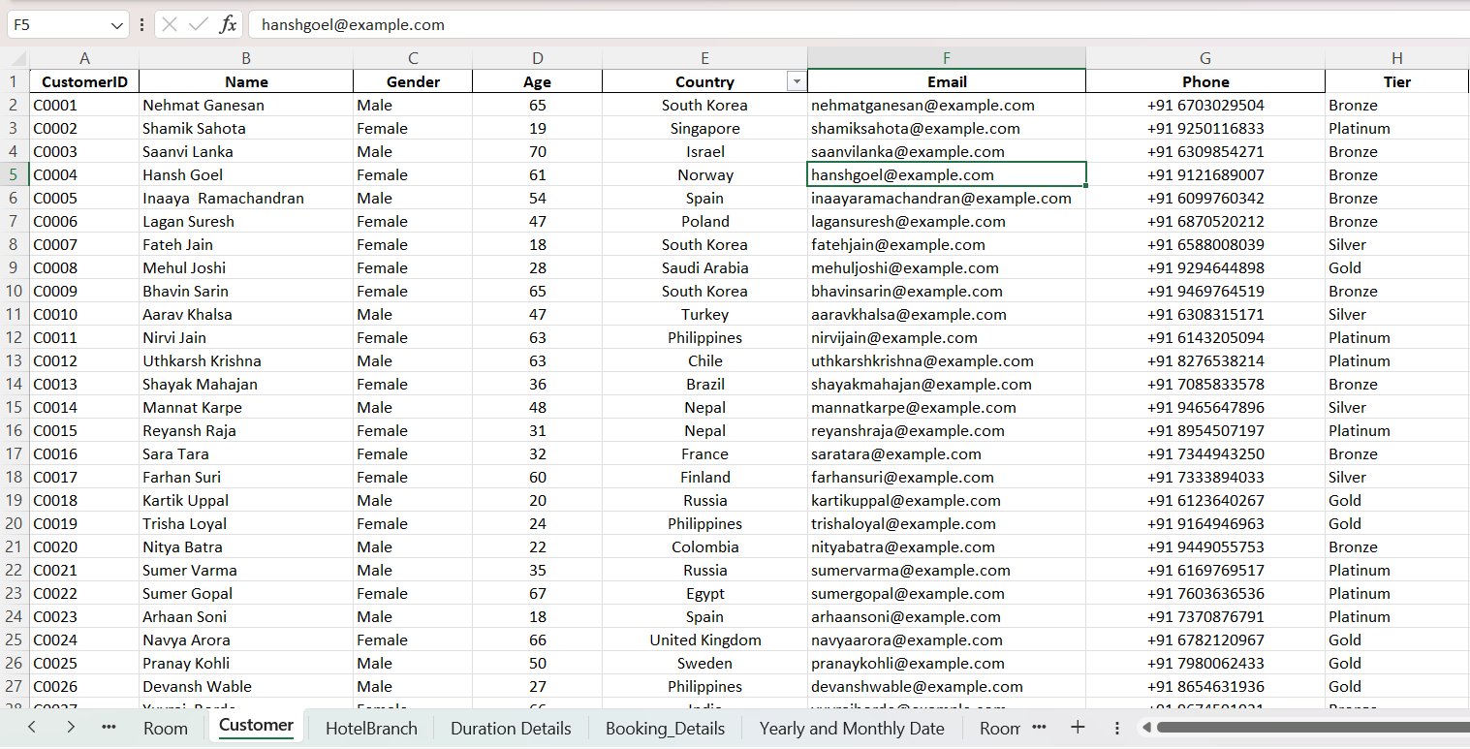

5. PowerBI Visuals Creation:
Guest Analysis Page
5.1 Visual 1: Nationality Distribution
- Visual Type: Stacked Bar Chart.
- Y-Axis: Country (from Customer table).
- X-Axis: Count of BookingID.
- Legend: GuestType (Business, Corporate, Family, Solo).
- Insight: Shows which countries drive specific types of travel (e.g., Russia/India driving Family vs Corporate).

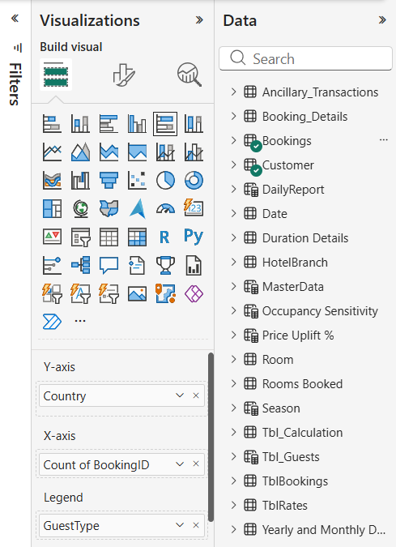
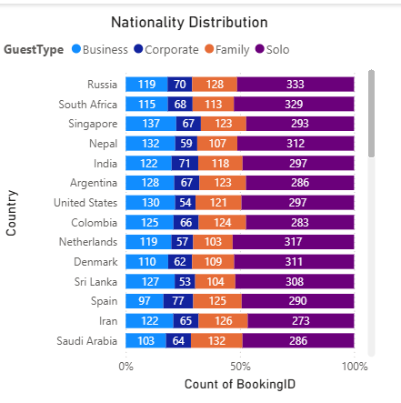

5.2 Visual 2: Booking Source Analysis
- Visual Type: 100% Stacked Column Chart.
- X-Axis: Booking Channel (Website, Travel Agent, Mobile App, etc.).
- Y-Axis: Count of BookingID.
- Legend: GuestType.
- Toggle Data Labels On
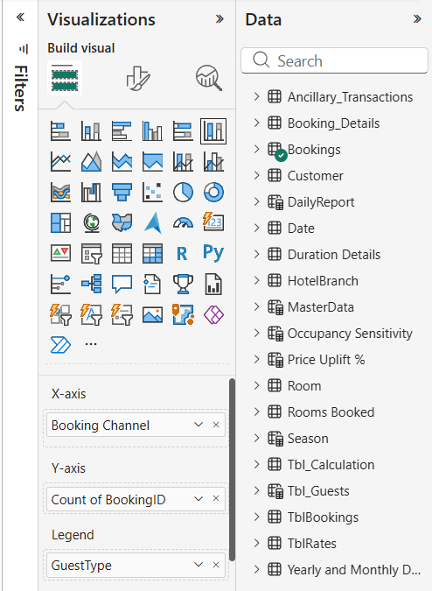
- Insight: Reveals channel preference. Example from slide: "Corporate Portal" is almost exclusively used by Business/Corporate travellers, whereas "Mobile App" has a high mix of Family travellers.
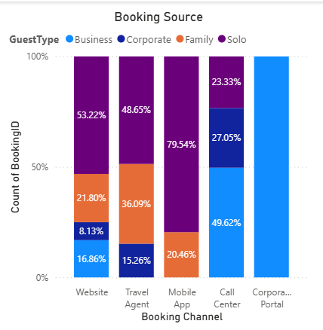
5.3 Visual 3: Average Nights Stayed by GuestType
- Visual Type: Clustered Column Chart.
- X-Axis: GuestType.
- Y-Axis: NightsStayed (Set aggregation to Average).
- Data Labels: Turn On.
- Go to Format (PaintBrush Icon) -> General -> Title -> Name as Average of Nights Stayed by Guest Type
- Insight: Example: Corporate and Family travelers stay longest (~5.5 nights), while Solo travelers stay the shortest (~3.2 nights).

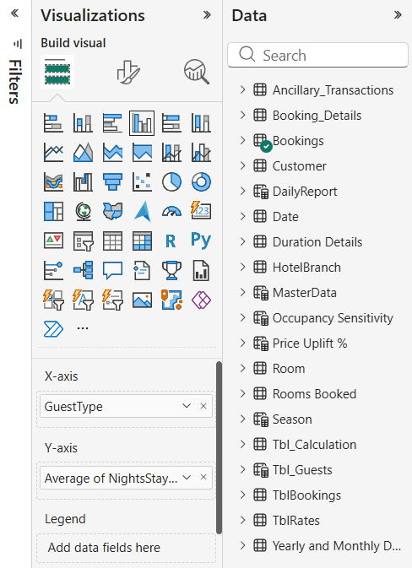
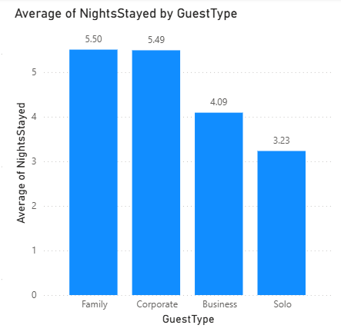

5.4 Visual4: Appointment Status by Gender:
- Visual Type: Pie Chart
- Legend: BookingStatus (Checked-in, No Show, Cancelled).
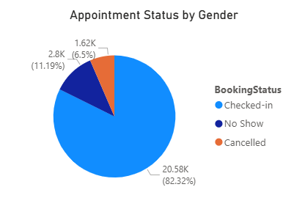
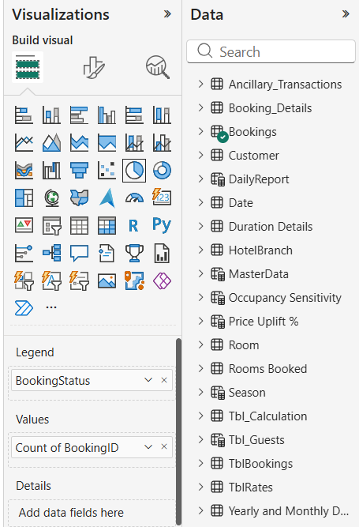
- Values: Count of BookingID.

5.5 Visual 5: Slicer
- Visual Type: Slicer
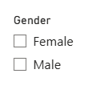
- Field: Gender

5.6 Visual 6: Payment Method by Gender:
- Visual Type : Pie Chart
- Legend: PaymentMethod (Credit Card, Online Wallet, UPI, Cash).
- Values: Total Payment (or Revenue).
- Insight: Credit Cards are the dominant payment method (purple slice).
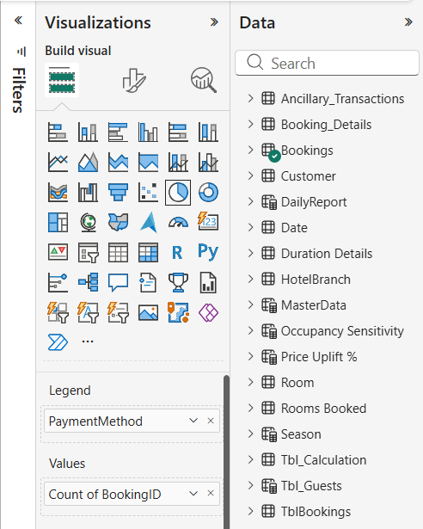
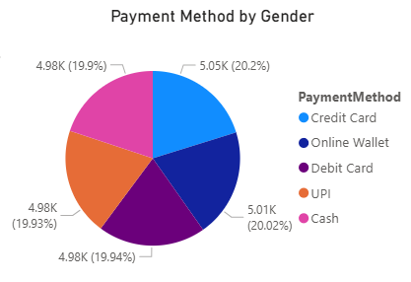

  - Visual 7: Total Payment by Gender:

- Visual Type: Pie Chart
- Legend: Gender.
- Values: Total Payment
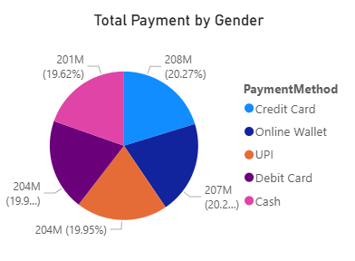
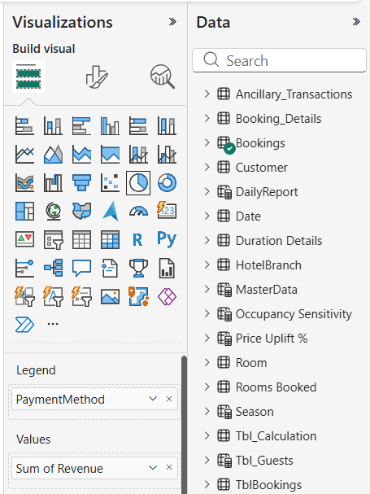
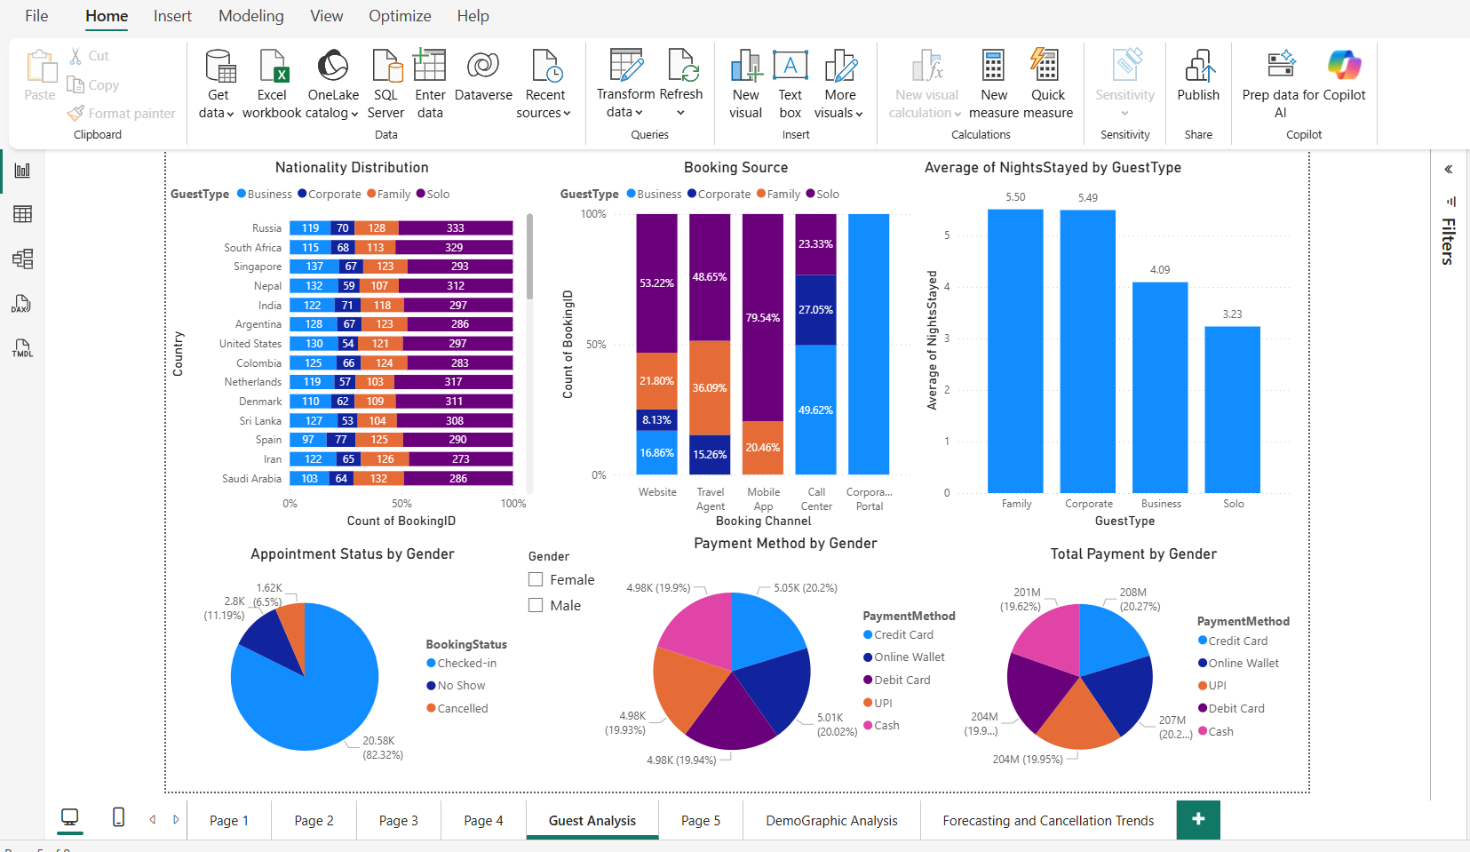

Page 5: Customer Cluster Analysis
Visual 1: Scatter Plot (RFM Matrix)
Goal: To plot customers based on their behavior scores, colored by their assigned cluster.
- Select Visual: Click on the Scatter Chart icon.
- Add Data (Drag fields to the Wells):
  - Values: Drag RecencyScore from the Tbl_Guests table.
  - X-Axis: Drag SpendScore.
    - Aggregation: Click the arrow next to the field and select Count
  - Y-Axis: Drag FrequencyScore.
    - Aggregation: Click the arrow next to the field and select Sum
  - Legend: Drag CustomerCluster.( from Bookings Table)
- Formatting:
  - Go to Format Visual (Paintbrush icon) $→$Markers.
  - Increase Size slightly to make the dots more visible.
  - Turn on Title and name it: "Count of SpendScore, Sum of FrequencyScore and RecencyScore by CustomerCluster".
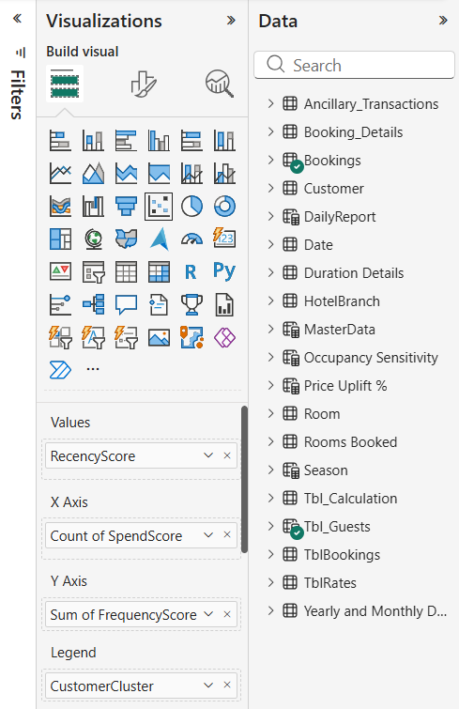
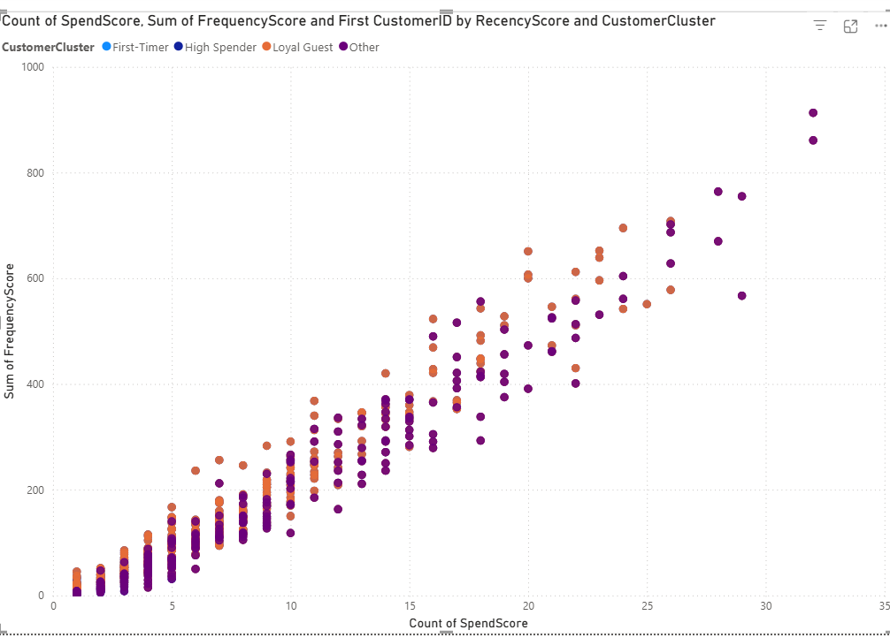

Visual 2: Hierarchy Slicer (Right Side)
Goal: To filter the scatter plot by specific segments.
- Select Visual: Click on the Slicer icon.
- Add Data:
  - Drag CustomerCluster into the field well.
  - Drag GuestType (Business, Family, etc.) immediately below CustomerCluster.
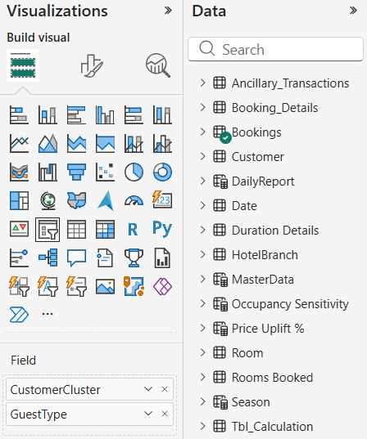
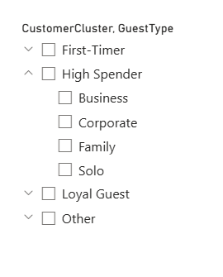
  - Result: This creates a hierarchy where you can expand "High Spender" to see "Business", "Family", etc.

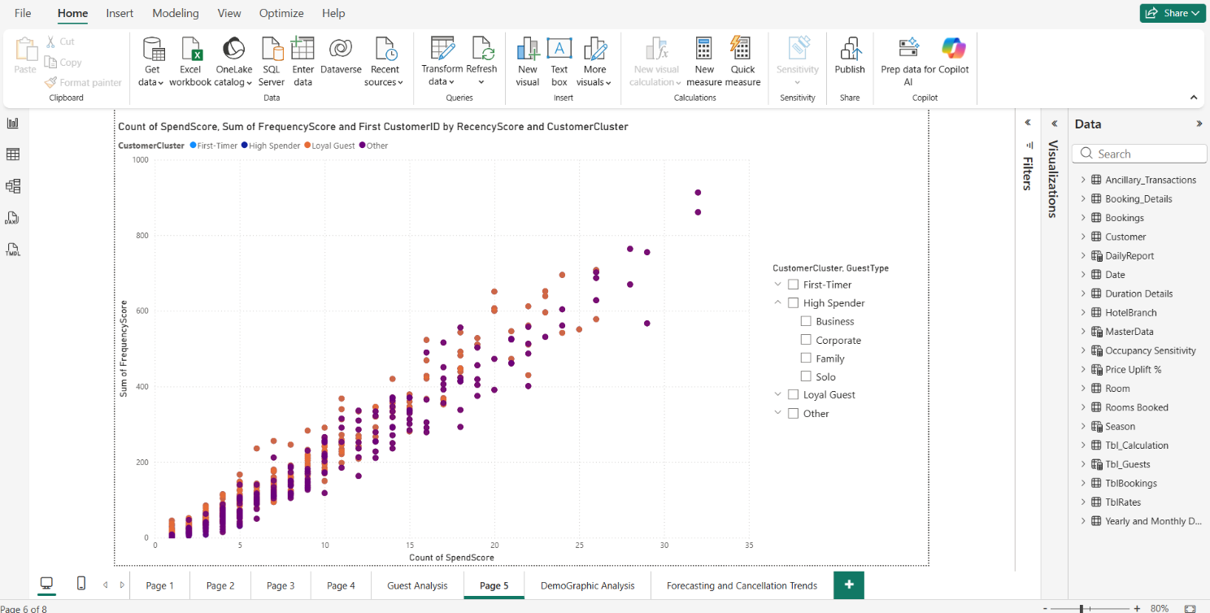
Page 6: Demographic Analysis

Visual 1: Customer by Country and CustomerCluster
Goal: See where different customer clusters are coming from globally.
- Select Visual: Click on the Map icon (Globe icon).
  - Note: Ensure "File > Options and settings > Options > Security > Map and Filled Map visuals" is enabled if the map doesn't load.
- Add Data:
  - Location: Drag Country (or Nationality) from the Tbl_Guests or Customer table.
  - Legend: Drag CustomerCluster.
    - Result: Pie charts will appear over countries showing the mix of clusters (e.g., USA might be mostly "High Spender").
  - Bubble Size: Drag CustomerID.
    - Aggregation: Select Count.
  - Title: "CustomerID by Country and CustomerCluster".

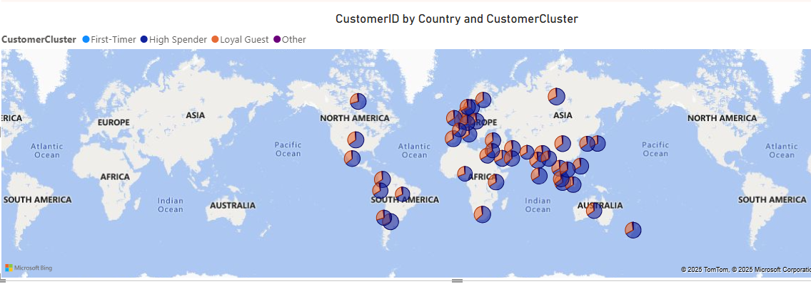
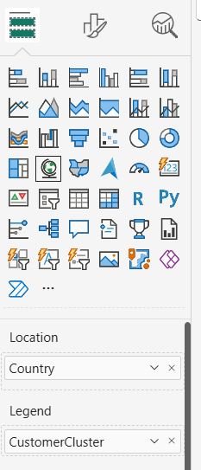

Visual 2: Booking Source by Visit Purpose
Goal: Analyse how different types of guests prefer to book (Direct vs. OTA).
- Select Visual: Click on the 100% Stacked Bar Chart icon.
- Add Data:
  - Y-Axis: Drag GuestType (Solo, Family, Business, Corporate).
  - X-Axis: Drag CustomerID.
    - Aggregation: Select Count.
  - Legend: Drag BookingSource (or SourceType).
- Formatting:
  - Data Labels: Toggle On.
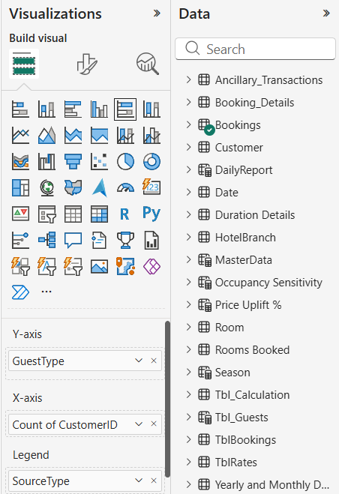
  - Title: "Booking Source by Visit Purpose".
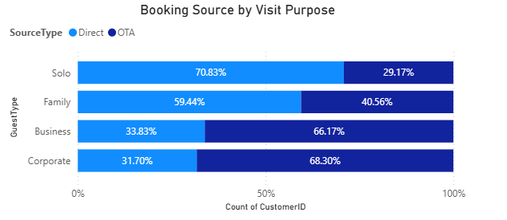

Visual 3: Slicer
Goal: Filter the page.
- Select Visual: Click on the Slicer icon.
- Add Data: Drag CustomerCluster and SourceType from Bookings Table
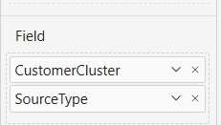
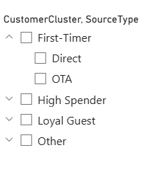

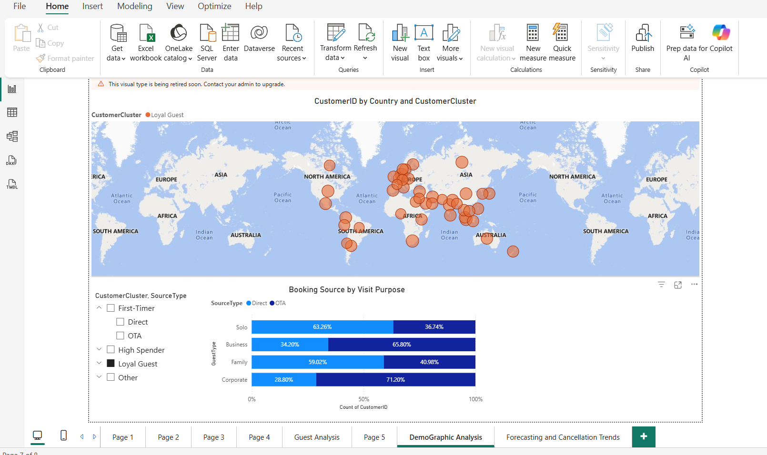

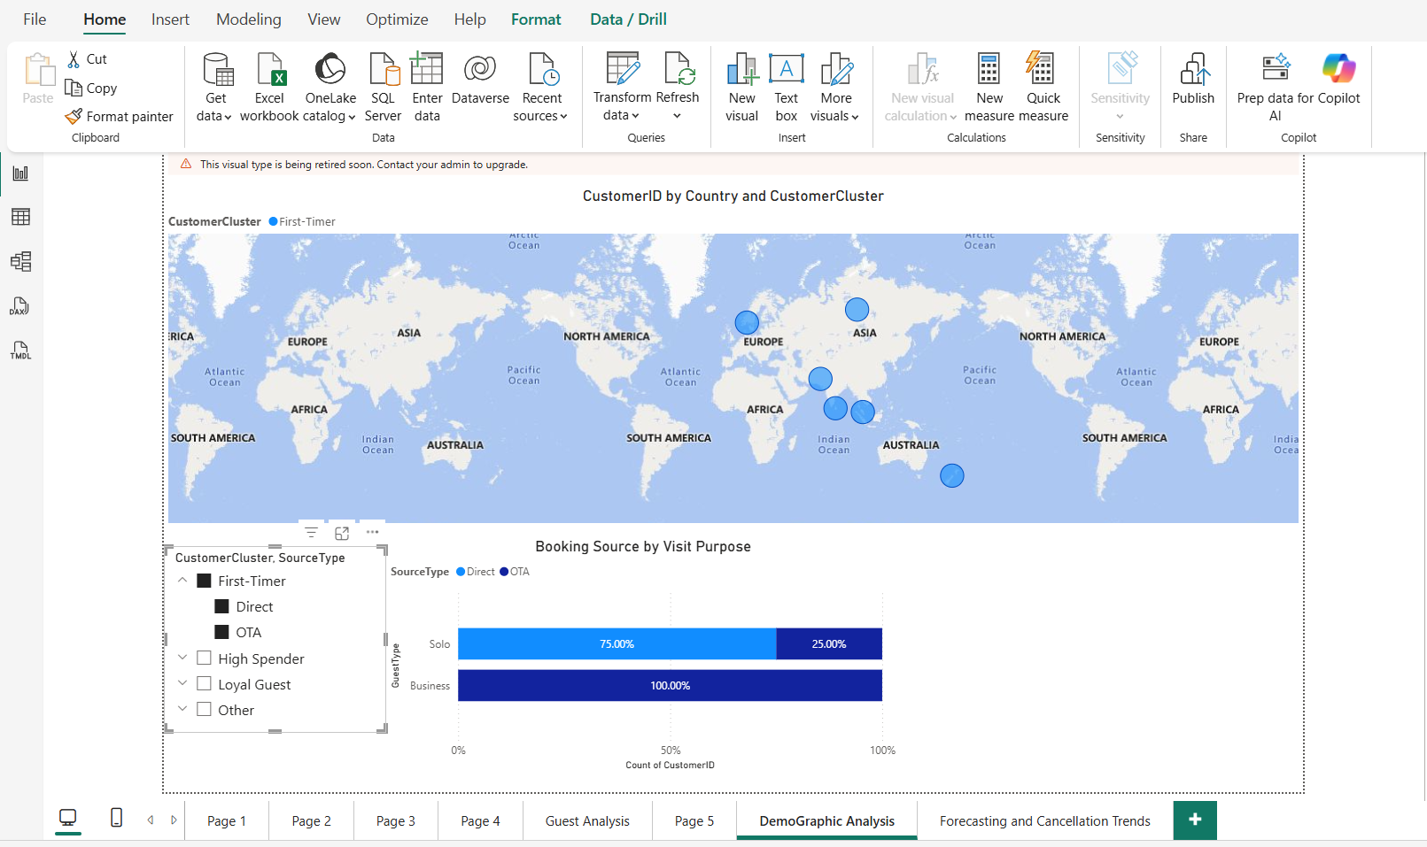
6. Insights:
6.1. Gender-Based Comparative Analysis
A. Geographic Origin (Nationality Distribution)
- Females: The top source countries for female travellers are Singapore, Sweden, and Russia. Singapore has a high volume of Business travelers (91) among women.
- Males: The top source countries for male travellers are the United States, India, and Sri Lanka.
B. Reliability (Appointment Status)
- Females: Have a higher Check-in rate (82.65%) and a lower cancellation/no-show rate.
- Males: Have a slightly lower Check-in rate (81.97%) and a higher combined Cancellation/No-Show rate (~18%).
C. Payment Preferences
- Females: Credit Cards are the #1 payment method by value (20.74%).
- Males: Online Wallets are the #1 payment method by volume (20.22%) and value (20.29%).

6.2 Overall Behavioural Insights (Gender Neutral)
A. Length of Stay is Purpose-Driven, Not Gender-Driven
- Comparing the "Average Nights Stayed" charts for Males vs. Females reveals almost identical behaviour:
  - Family: ~5.5 nights (Both genders)
  - Corporate: ~5.5 nights (Both genders)
  - Business: ~4.1 nights (Both genders)
  - Solo: ~3.2 nights (Both genders)
B. Booking Channel Segmentation
- Corporate Portal: This channel is used exclusively by Business Travelers
- Mobile App: This is the channel of choice for Solo Travelers (Purple bar is ~80%).
- Travel Agents: This channel has the most diverse mix, balancing Family, Corporate, and Solo travellers.
C. Payment Ecosystem
- Looking at the "Total Payment by Gender" charts, the revenue split is incredibly balanced (~20% per method) across Credit Cards, UPI, Wallets, Cash, and Debit Cards.

  - Insights from Geographic Analysis:

6.3.1 "First-Timer" Cluster Analysis

- Geographic Reach: First-time guests are scattered thinly across the globe, with very few distinct concentrations. This indicates no specific region is currently driving new customer acquisition.

- Booking Behaviour (The 100% Split):
  - Business Travelers: 100% of new business guests book via OTAs. This means the hotel is paying a commission for every single new business client.

  - Solo Travelers: 75% book Directly. This is a great sign as new solo travellers find the hotel website easily and book it without an agent.

6.3.2 "High Spender" Cluster Analysis

- Geographic Reach: This cluster has a high density in North America (USA), Europe, and South America. These are the key regions contributing the most revenue.

- Booking Behavior:
  - Most Profitable: Solo High Spenders prefer Direct Bookings (78.86%). This is the most profitable segment for the hotel (High Revenue + No Commission).
  - High Cost: Corporate and Business High Spenders still rely heavily on OTAs (~66-68%). Even though they spend a lot, the hotel loses a significant chunk of that money to commission fees.

6.3.3 "Loyal Guest" Cluster Analysis

- Geographic Reach: The map for Loyal Guests looks very similar to High Spenders, confirming that the hotel's retention strategy works best in Western markets (Europe/Americas) and India.

- Booking Behavior:
  - Corporate Stickiness: Even Loyal Corporate Guests continue to use OTAs (71.20%). Loyalty has not convinced them to switch to Direct Booking, likely due to strict company travel policies.
  - Solo Drop: Interestingly, Loyal Solo travelers use Direct booking less (63.26%) than High Spender Solo travelers (78.86%). This suggests that over time, some loyal solo guests drift back to using apps/OTAs for convenience.

7. Conclusion
The data shows that Men and Women behave remarkably similarly regarding how long they stay and how they book. The key differences lie in where they come from (Nationality) and slightly in reliability (Women cancel less)
Direct Booking Wins: Solo Travelers are the champions of Direct Booking across all clusters. They offer the highest profit margins.
OTA Dependency: Business and Corporate guests are "stuck" on OTAs, regardless of whether they are new or loyal. The hotel is unable to shift this behaviour.

